Unequal-Base Spherical Segment
# Source: AI Source: Provided by: [Data Path: Persons Table -> ID Column: 1, Name_En Column: Motasem Essam] -> From: [ChatGPT] on [7/25/2026]
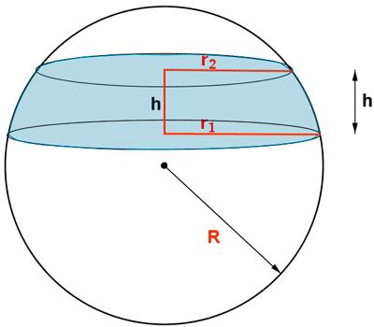
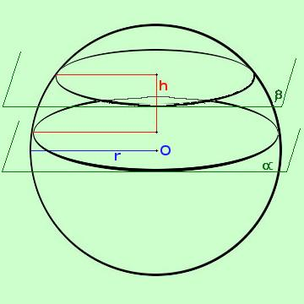
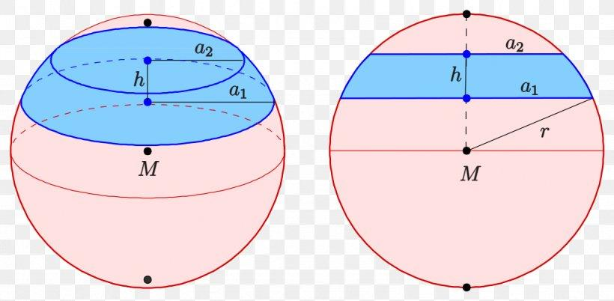

Definition
# Source: AI Source: Provided by: [Data Path: Persons Table -> ID Column: 1, Name_En Column: Motasem Essam] -> From: [ChatGPT] on [7/25/2026]
An unequal-base spherical segment is a portion of a solid sphere bounded by two parallel planes that intersect the sphere at different distances from its center, producing two circular bases of different radii.
The solid includes the curved spherical surface between the two cutting planes and the two circular end faces. Because the planes are at different distances from the sphere's center, the base circles have unequal radii.
It is a type of spherical segment.

Simple Definition
# Source: AI Source: Provided by: [Data Path: Persons Table -> ID Column: 1, Name_En Column: Motasem Essam] -> From: [ChatGPT] on [7/25/2026]
An unequal-base spherical segment is a slice of a sphere between two parallel planes that has two circular bases of different sizes.

Geometric Elements
# Source: AI Source: Provided by: [Data Path: Persons Table -> ID Column: 1, Name_En Column: Motasem Essam] -> From: [ChatGPT] on [7/25/2026]
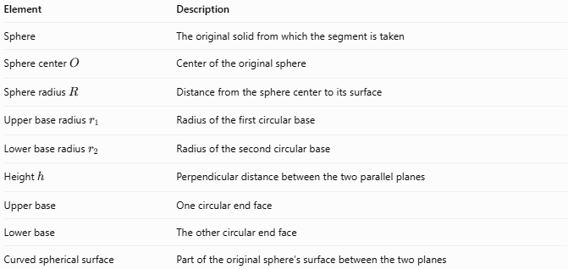
Element | Description
Sphere | The original solid from which the segment is taken
Sphere center $O$ | Center of the original sphere
Sphere radius $R$ | Distance from the sphere center to its surface
Upper base radius $r_{1}$ | Radius of the first circular base
Lower base radius $r_{2}$ | Radius of the second circular base
Height $h$ | Perpendicular distance between the two parallel planes
Upper base | One circular end face
Lower base | The other circular end face
Curved spherical surface | Part of the original sphere's surface between the two planes
The labels “upper” and “lower” are conventional; either base may be larger, depending on the position of the planes.

Mathematical Properties and Formulas
# Source: AI Source: Provided by: [Data Path: Persons Table -> ID Column: 1, Name_En Column: Motasem Essam] -> From: [ChatGPT] on [7/25/2026]
Let:
- $R$ = radius of the original sphere
- $h$ = distance between the two parallel planes
- $r_{1},r_{2}$ = radii of the two bases
- $V$ = volume of the segment
- $A_{c}$ = curved surface area
- $A_{t}$ = total surface area, including both circular bases

Unequal-Base Condition
# Source: AI Source: Provided by: [Data Path: Persons Table -> ID Column: 1, Name_En Column: Motasem Essam] -> From: [ChatGPT] on [7/25/2026]
$$\boxed{r_{1}≠r_{2}}$$
For a sphere, the radius of a circular cross-section depends on its distance from the center. If the two planes are at different absolute distances from the center, their base radii differ.

Base Radii
# Source: AI Source: Provided by: [Data Path: Persons Table -> ID Column: 1, Name_En Column: Motasem Essam] -> From: [ChatGPT] on [7/25/2026]
If a cutting plane is at perpendicular distance $d$ from the sphere center, its circular intersection has radius
$$r=\sqrt{R^{2}-d^{2}}$$
For the two bases:
$$r_{1}=\sqrt{R^{2}-d_{1}^{2}}$$
$$r_{2}=\sqrt{R^{2}-d_{2}^{2}}$$
where $d_{1}$ and $d_{2}$ are the signed distances from the center when assigning positions along a chosen axis; the radius calculation uses their squares.

Volume
# Source: AI Source: Provided by: [Data Path: Persons Table -> ID Column: 1, Name_En Column: Motasem Essam] -> From: [ChatGPT] on [7/25/2026]
The volume of a spherical segment with two circular bases is
$$\boxed{V=\frac{πh}{6}\left(3r_{1}^{2}+3r_{2}^{2}+h^{2}\right)}$$
This formula applies when $h$ is the perpendicular distance between the two parallel base planes and $r_{1},r_{2}$ are the radii of the bases.

Curved Surface Area
# Source: AI Source: Provided by: [Data Path: Persons Table -> ID Column: 1, Name_En Column: Motasem Essam] -> From: [ChatGPT] on [7/25/2026]
The curved surface area is
$$\boxed{A_{c}=2πRh}$$
Here, $R$ is the radius of the original sphere, not either base radius.

Total Surface Area
# Source: AI Source: Provided by: [Data Path: Persons Table -> ID Column: 1, Name_En Column: Motasem Essam] -> From: [ChatGPT] on [7/25/2026]
The total surface area includes the curved surface and both circular bases:
$$A_{t}=A_{c}+πr_{1}^{2}+πr_{2}^{2}$$
Therefore,
$$\boxed{A_{t}=2πRh+π\left(r_{1}^{2}+r_{2}^{2}\right)}$$

Worked Example
# Source: AI Source: Provided by: [Data Path: Persons Table -> ID Column: 1, Name_En Column: Motasem Essam] -> From: [ChatGPT] on [7/25/2026]
A sphere has radius $R=10\text{ cm}$. Two parallel planes are located at signed distances $3\text{ cm}$ and $7\text{ cm}$ from its center on the same side. Find the base radii, segment height, volume, curved surface area, and total surface area.
Given
$$R=10\text{ cm}, d_{1}=3\text{ cm}, d_{2}=7\text{ cm}$$
Step 1 — Calculate the base radii
$$\begin{aligned}r_{1}&=\sqrt{{10}^{2}-3^{2}}=\sqrt{91} \\ r_{2}&=\sqrt{{10}^{2}-7^{2}}=\sqrt{51}\end{aligned}$$
Thus,
$$r_{1}≈9.54\text{ cm}, r_{2}≈7.14\text{ cm}$$
The base radii are unequal, so this is an unequal-base spherical segment.
Step 2 — Calculate the height
Since both planes lie on the same side of the center,
$$h=\left|d_{2}-d_{1}\right|=\left|7-3\right|=4\text{ cm}$$
Step 3 — Calculate the volume
$$\begin{aligned}V&=\frac{πh}{6}\left(3r_{1}^{2}+3r_{2}^{2}+h^{2}\right) \\ &=\frac{4π}{6}\left(3\left(91\right)+3\left(51\right)+16\right) \\ &=\frac{4π}{6}\left(442\right) \\ &=\frac{884π}{3}\end{aligned}$$
$$\boxed{V≈925.75{\text{ cm}}^{3}}$$
Step 4 — Calculate the curved surface area
$$A_{c}=2π\left(10\right)\left(4\right)=80π$$
$$\boxed{A_{c}≈251.33{\text{ cm}}^{2}}$$
Step 5 — Calculate the total surface area
$$\begin{aligned}A_{t}&=2πRh+π\left(r_{1}^{2}+r_{2}^{2}\right) \\ &=80π+π\left(91+51\right) \\ &=222π\end{aligned}$$
$$\boxed{A_{t}≈697.43{\text{ cm}}^{2}}$$

Comparison with Related Solids
# Source: AI Source: Provided by: [Data Path: Persons Table -> ID Column: 1, Name_En Column: Motasem Essam] -> From: [ChatGPT] on [7/25/2026]
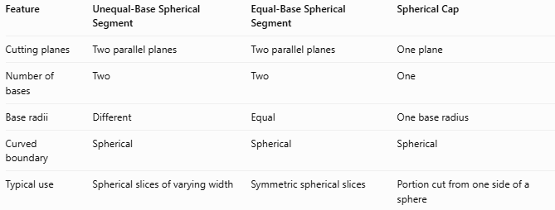
Feature | Unequal-Base Spherical Segment | Equal-Base Spherical Segment | Spherical Cap
Cutting planes | Two parallel planes | Two parallel planes | One plane
Number of bases | Two | Two | One
Base radii | Different | Equal | One base radius
Curved boundary | Spherical | Spherical | Spherical
Typical use | Spherical slices of varying width | Symmetric spherical slices | Portion cut from one side of a sphere
A spherical cap has one circular base, while a spherical segment lies between two parallel planes and generally has two circular bases.

Applications
# Source: AI Source: Provided by: [Data Path: Persons Table -> ID Column: 1, Name_En Column: Motasem Essam] -> From: [ChatGPT] on [7/25/2026]
- Engineering: Calculating volumes of spherical components cut by parallel planes.
- Manufacturing: Measuring spherical parts with two different circular end faces.
- Architecture: Modeling sections of spherical domes and curved structures.
- Fluid storage: Estimating the volume contained within a portion of a spherical vessel.
- Geometry and CAD: Modeling and calculating spherical solids created by plane intersections.

Key Points
# Source: AI Source: Provided by: [Data Path: Persons Table -> ID Column: 1, Name_En Column: Motasem Essam] -> From: [ChatGPT] on [7/25/2026]
- An unequal-base spherical segment is bounded by two parallel planes.
- Its two circular bases have different radii: $r_{1}≠r_{2}$.
- Its height is the perpendicular distance between the planes.
- The curved surface area is $2πRh$.
- Its total surface area includes both base disks.
- The volume formula requires the height and both base radii.
- Base radii depend on each plane's distance from the sphere's center.

Conclusion
# Source: AI Source: Provided by: [Data Path: Persons Table -> ID Column: 1, Name_En Column: Motasem Essam] -> From: [ChatGPT] on [7/25/2026]
An Unequal-Base Spherical Segment is a solid portion of a sphere between two parallel cutting planes that create circular bases of different radii. Its defining feature is the unequal size of those bases. Using the sphere radius, segment height, and base radii, its volume and surface areas can be calculated precisely.

